Project Planning Phase
Project Planning Template (Product Backlog, Sprint Planning, Stories, Story points)
Date | 18 june 2026
Team ID
Project Name | HOUSE RENT
Maximum Marks | 5 Marks
Product Backlog, Sprint Schedule, and Estimation (4 Marks)
Product Backlog and Sprint Schedule as follows:
Product Backlog
Sprint | Functional Requirement (Epic) | User Story Number | User Story / Task | Story Points | Priority | Team Members
Sprint-1 | User Registration | USN-1 | As a user, I can register an account using my name, email, password, and role. | 3 | High | Bhavishya Reddy
Sprint-1 | User Login | USN-2 | As a user, I can log in using valid credentials. | 2 | High | Bhavishya Reddy
Sprint-1 | Authentication | USN-3 | As a user, I can securely access my account after login. | 2 | High | Bhavishya Reddy
Sprint-2 | Property Listings | USN-4 | As a user, I can browse all available properties. | 3 | High | Bhavishya Reddy
Sprint-2 | Property Search | USN-5 | As a user, I can search properties using keywords or location. | 2 | High | Bhavishya Reddy
Sprint-2 | Property Filtering | USN-6 | As a user, I can filter properties by price, type, and location. | 2 | Medium | Bhavishya Reddy
Sprint-3 | Property Details | USN-7 | As a user, I can view detailed information about a property. | 3 | High | Bhavishya Reddy
Sprint-3 | Favorites/Wishlist | USN-8 | As a user, I can save properties to my favorites list. | 2 | Medium | Bhavishya Reddy
Sprint-3 | Property Inquiry | USN-9 | As a user, I can contact the property owner regarding a property. | 3 | High | Bhavishya Reddy
Sprint-4 | Booking Management | USN-10 | As a user, I can view my booking and inquiry history. | 2 | Medium | Bhavishya Reddy
Sprint-4 | Admin Dashboard | USN-11 | As an admin, I can access the admin dashboard. | 3 | High | Bhavishya Reddy
Sprint-4 | Property Management | USN-12 | As an admin, I can add new property listings. | 3 | High | Bhavishya Reddy
Sprint-5 | Property Management | USN-13 | As an admin, I can update existing property listings. | 2 | High | Bhavishya Reddy
Sprint-5 | Property Management | USN-14 | As an admin, I can delete property listings. | 2 | High | Bhavishya Reddy
Sprint-5 | User Management | USN-15 | As an admin, I can manage registered users. | 3 | Medium | Bhavishya Reddy
Sprint-5 | Inquiry Management | USN-16 | As an admin, I can view and manage user inquiries and bookings. | 3 | High | Bhavishya Reddy

Project Tracker, Velocity & Burndown Chart
Sprint | Total Story Points | Duration | Sprint Start Date | Sprint End Date (Planned) | Story Points Completed | Sprint Release Date (Actual)
Sprint-1 | 15 | 5 Days | 20 May 2026 | 24 May 2026 | 15 | 24 May 2026
Sprint-2 | 18 | 6 Days | 26 May 2026 | 31 May 2026 | 18 | 31 May 2026
Sprint-3 | 20 | 6 Days | 02 Jun 2026 | 07 Jun 2026 | 20 | 07 Jun 2026
Sprint-4 | 18 | 5 Days | 09 Jun 2026 | 13 Jun 2026 | 18 | 13 Jun 2026
Sprint-5 | 16 | 4 Days | 14 Jun 2026 | 17 Jun 2026 | 16 | 17 Jun 2026

Velocity
Velocity represents the average number of story points completed during each sprint. For the House Hunt project, a total of 87 story points were completed across 5 sprints, resulting in an average velocity of 17.4 story points per sprint.
Velocity Calculation
Total Story Points Completed = 87
Number of Sprints = 5
Velocity = Total Story Points Completed ÷ Number of Sprints
Velocity = 87 ÷ 5
Velocity = 17.4 Story Points per Sprint
Interpretation
- The development team completed an average of 17.4 story points in each sprint.
- The velocity indicates a consistent development pace throughout the project.
- This metric helped in planning future sprints and estimating the completion of remaining features.
- The achieved velocity demonstrates efficient progress in implementing key functionalities such as user authentication, property listing management, property search and filtering, inquiry handling, and admin management features for the House Hunt application.
Burndown Chart
A Burndown Chart is a graphical representation of the amount of work remaining versus time. It is commonly used in Agile and Scrum methodologies to track project progress and determine whether the team is on schedule to complete the project within the planned timeframe.
For the House Hunt Project, the burndown chart tracks the remaining story points after each sprint. As work is completed, the remaining story points decrease until they reach zero at project completion.
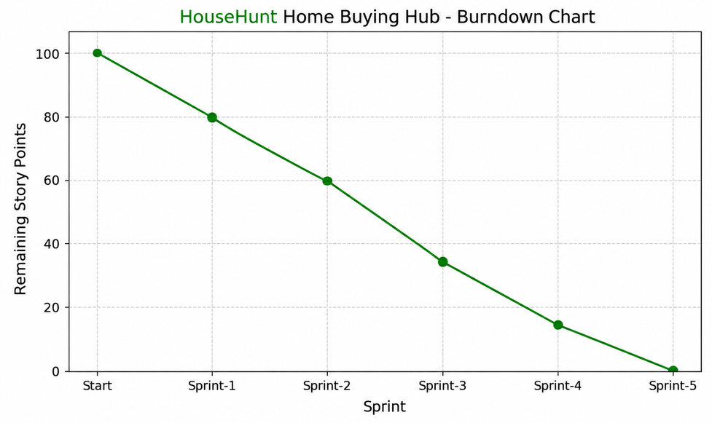
Burndown Analysis
The burndown chart for the House Hunt Project shows a consistent and steady reduction in the remaining story points throughout all five sprints. The project began with 87 total story points, covering key functionalities such as user registration and login, property listing management, property search and filtering, property inquiry handling, favorites management, and admin operations.
Key Observations:
- Consistent progress was achieved across all sprints.
- No major backlog remained at the end of the project.
- Sprint goals were completed within the planned duration.
- The team maintained a healthy velocity throughout development.
- The House Hunt project was successfully completed and ready for deployment by the end of Sprint-5.

